Tenda MW5s- How to remove one of three MW5s nodes?

User Scenario: I bought a suite (3 nodes), I want to give one of three nodes to my friend and use independently.

You need to remove the node from Tenda Wi-Fi App.

Step 1: Open App, tap the node you want to remove;

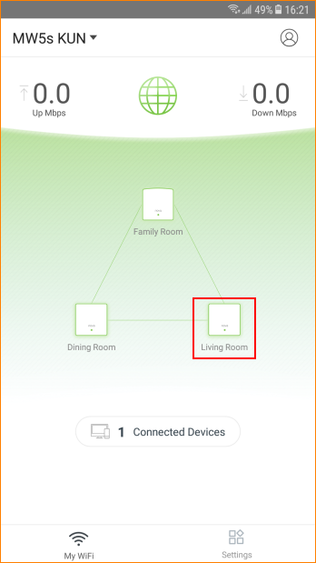

Step 2: Tap “…” on top right

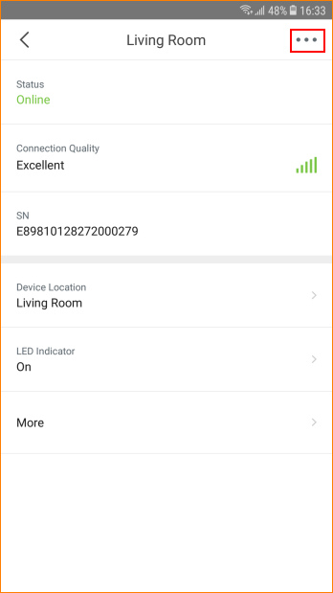

Step 3: Tap “Delete” to remove the node

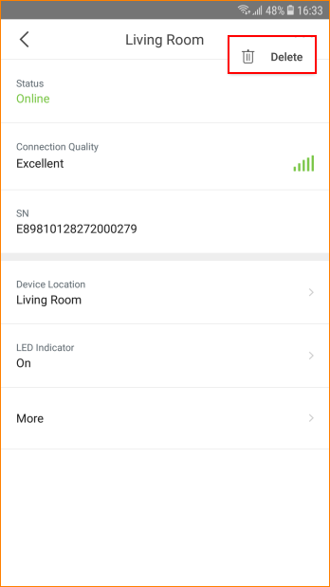

Note:

In one suite all nodes are in the same mesh network system. When you configure primary node (The first one you configure) to access internet, other nodes will synchronize configurations of primary node (E.g: SSID and password.)

